HOW TO ADD WAS AWARD TO HRD V5
Download both the award definition and the loader code to a known location on the computer
CHANGES if Custom Field 6 already used.
- Open the XML file for the award definition
- Locate the ‘Award = “ entry and change value ‘6’ to ‘5’ or ‘4’ as per your current usage,
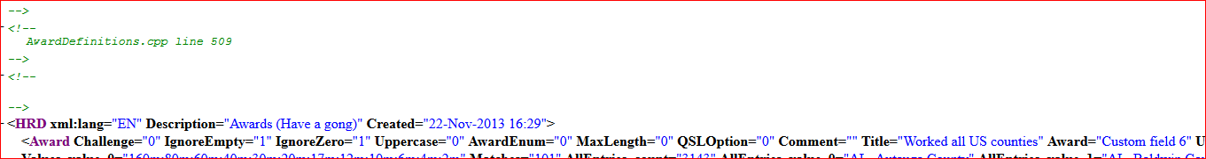
When Custom Field selected then:
- Open HRD logbook and select award tracking tab
- Go to Definitions
- Select Import
- In File Select dialogue select the awards definition file which was downloaded and click Open
- We now need data so start the data loading application previously downloaded (I have shortcut on desktop)
- Select the Custom Field you have selected in Part 1 and start
- Dialogue should confirm data now loaded into the selected Custom field,
- Go back to award tracking and check data is now present in the results table
- Click a displayed record and NO DATA SHOWS. You need to change the Match dropdown on the top to ‘Contains’ and details of the QSO will show. (No idea why)
- Double Click the contact information then select the ‘Custom’ tab in the lower section,
- Use the configure dialogue to change the field name to whatever you want
DONE

